1) One LED Blink

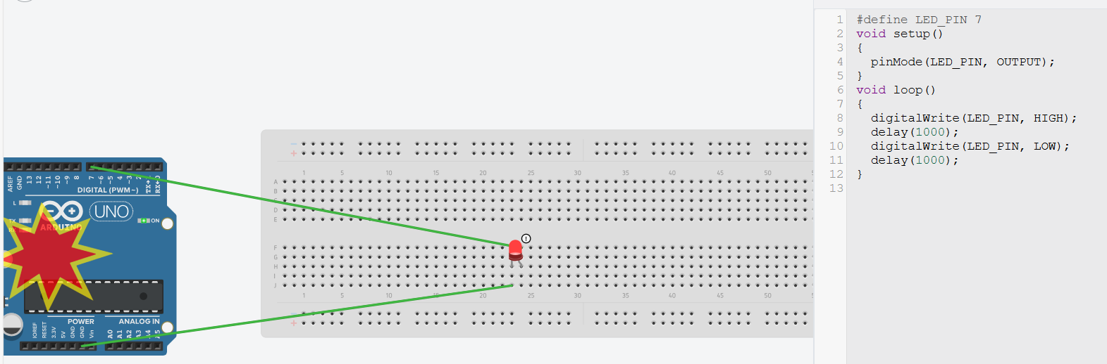

LED :- Big = Anode = positive
Small = Cathode = negative
2) 3 LED Blink
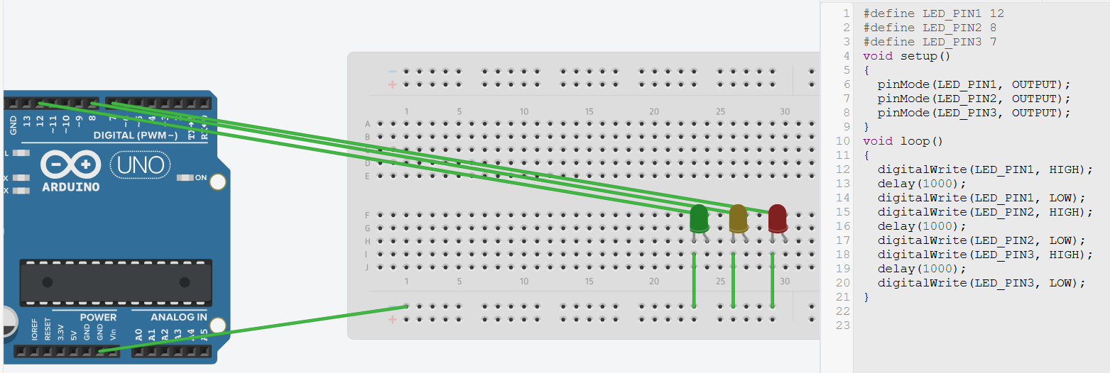

3) 8. NodeMCU + LED
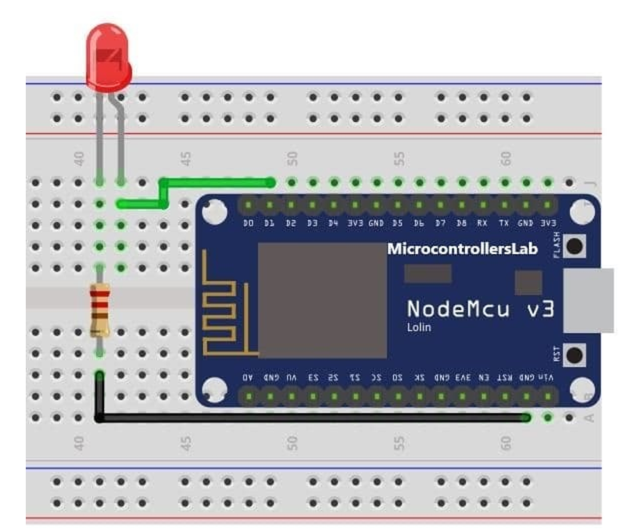
4) 9. NodeMCU + 3 LEDs
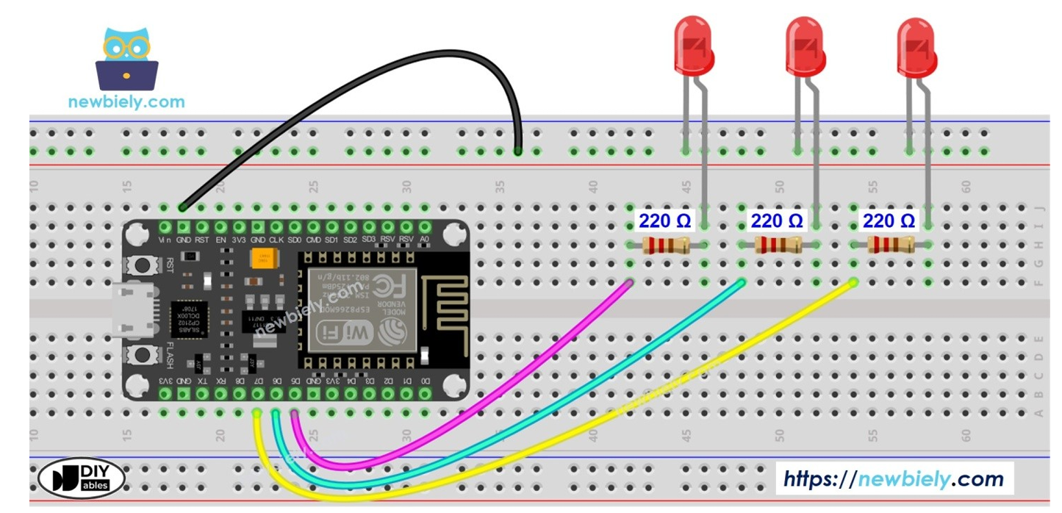

Same code as above just replace evry where with resprctive numbers like D5 D6 D7 at starting near LED_PIN1,2,3

5) 2. Pushbutton + LED
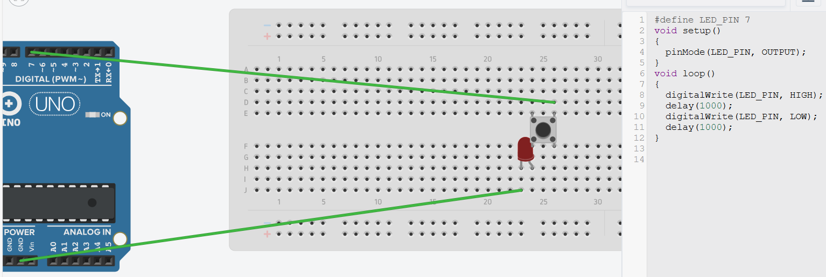
#define LED_PIN1 12 #define LED_PIN 8
#define LED_PIN2 8 void setup()
#define LED_PIN3 7 {
void setup() pinMode(LED_PIN, OUTPUT);
{ }
pinMode(LED_PIN1, OUTPUT); void loop()
pinMode(LED_PIN2, OUTPUT); {
pinMode(LED_PIN3, OUTPUT); digitalWrite(LED_PIN, HIGH);
} delay(1000);
void loop() digitalWrite(LED_PIN, LOW);
{ delay(1000);
digitalWrite(LED_PIN1, HIGH); }
delay(1000);
digitalWrite(LED_PIN1, LOW); ( it can be 12,13,8,7,2 )
digitalWrite(LED_PIN2, HIGH);
delay(1000);
digitalWrite(LED_PIN2, LOW);
digitalWrite(LED_PIN3, HIGH);
delay(1000);
digitalWrite(LED_PIN3, LOW);
}

6) 5. Potentiometer + LED
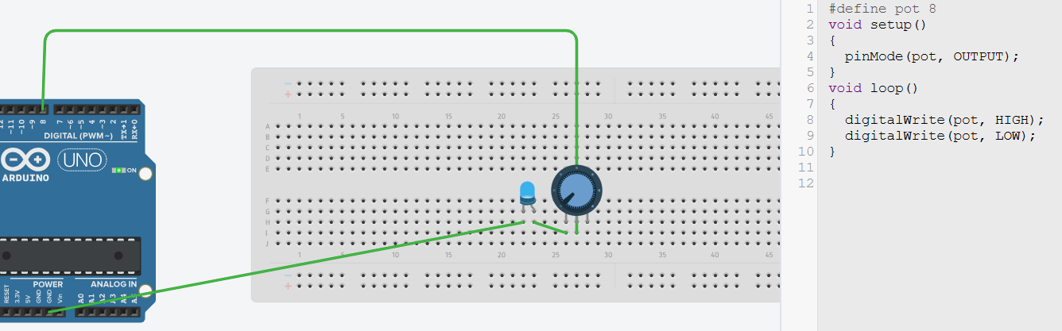
Replace LED_PIN with pot and delete delay
7) 4. Buzzer
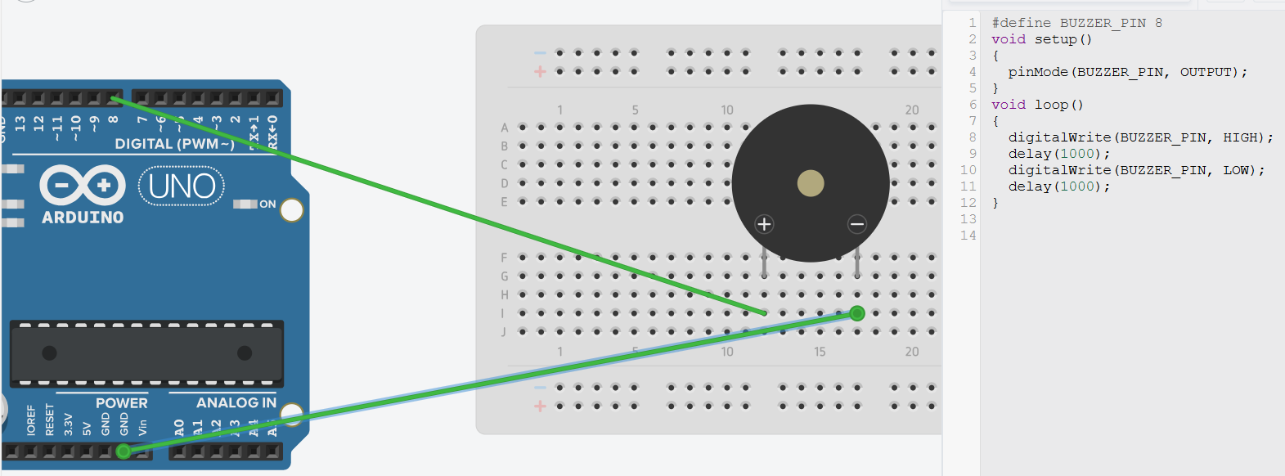
Replace LED_PIN with BUZZER_PIN
8) 7. LM35
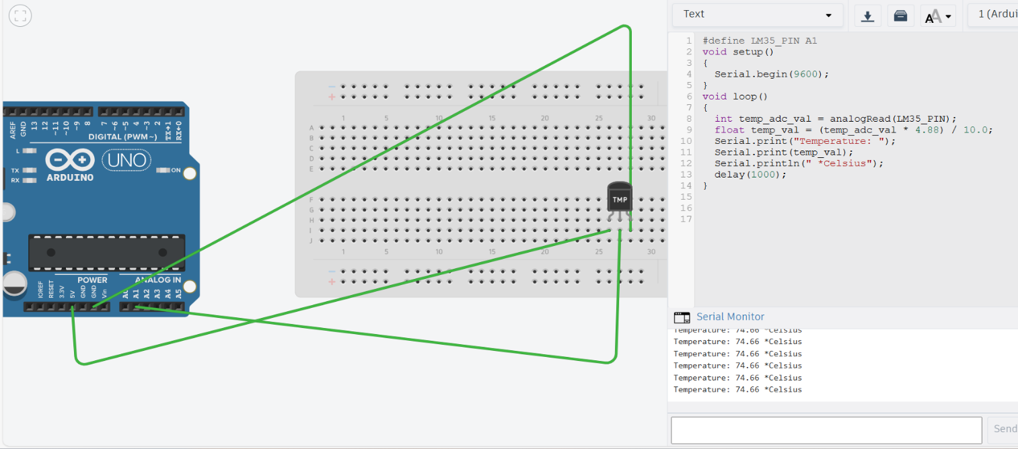
#define LM35_PIN A1
void setup()
{
Serial.begin(9600);
}
void loop()
{
int temp_adc_val = analogRead(LM35_PIN);
float temp_val = (temp_adc_val * 4.88) / 10.0; // Convert ADC value to temperature in °C
// [ int temp_val = temp_adc_val * 4.88;
temp_val = temp_val/10; ] //
Serial.print("Temperature: ");
Serial.print(temp_val);
Serial.println(" *Celsius");
delay(1000);
}
9) 6. DHT11
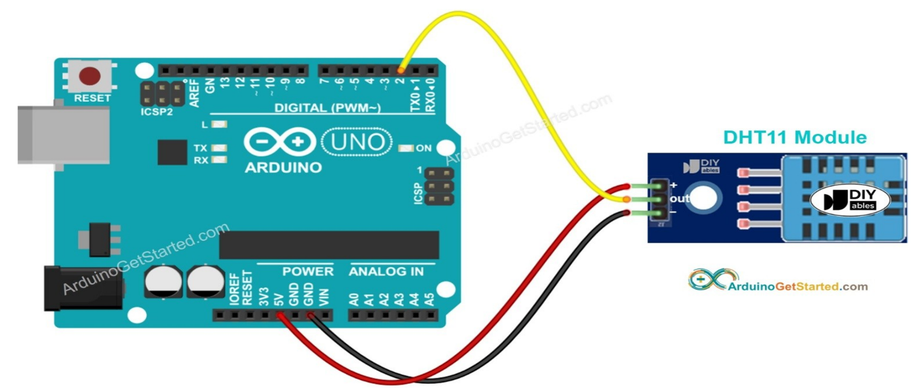

10) 10. NodeMCU + DHT11
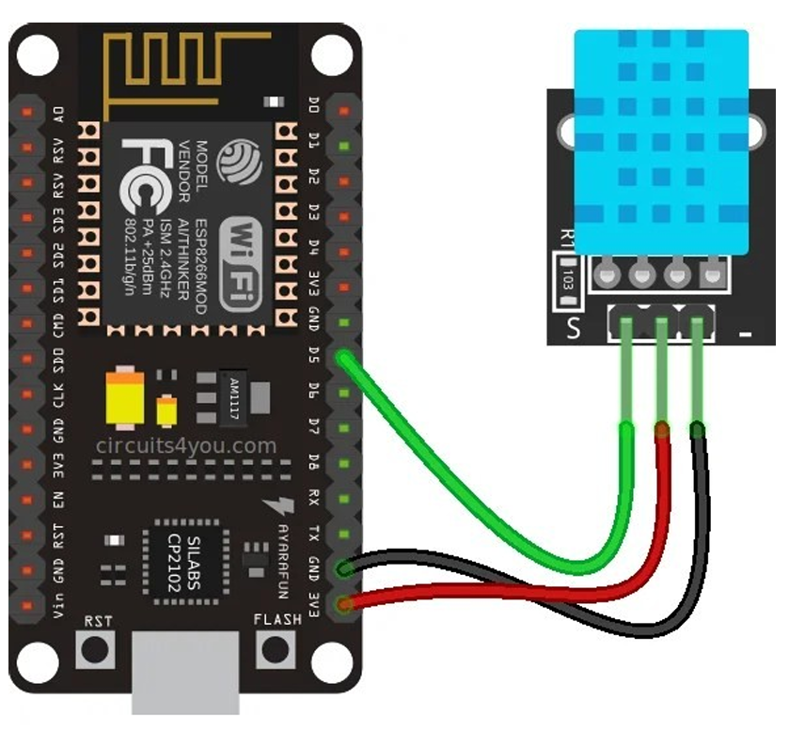
VCC = 3E3 / 5V
DAT = D2 / 7V (Declare DAT)
GND (-) = GND

#include "DHT.h"
#define DHT_PIN 5/D2(DAT middle)
#define DHTTYPE DHT11
DHT dht(DHT_PIN, DHTTYPE);
void setup()
{
Serial.begin(9600);
dht.begin();
}
void loop()
{
float h = dht.readHumidity();
float t = dht.readTemperature(); // Temperature in Celsius
float f = dht.readTemperature(true); // Temperature in Fahrenheit
float hi = dht.computeHeatIndex(f, h); // Heat index in Fahrenheit
Serial.print("Humidity: ");
Serial.print(h);
Serial.print(" %\t");
Serial.print("Temperature: ");
Serial.print(t);
Serial.print(" C\t");
Serial.print(f);
Serial.print(" F\t");
Serial.print("Heat Index: ");
Serial.print(hi);
// [ Serial.println(" F");
delay(2000); // Delay between readings ] //
}

